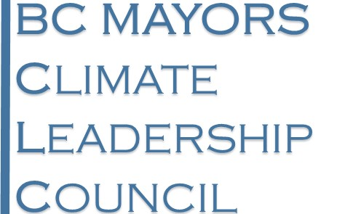
FOR IMMEDIATE RELEASE
April 7, 2016

B.C. mayors call for stronger carbon tax, more transit funding and greener building standards

Local governments are important partners in climate action, B.C. Mayors Climate Leadership Council says
NORTH VANCOUVER — A group of mayors representing a cross-section of the province’s large and small communities have laid out a clear vision for climate leadership in British Columbia.
The B.C. Mayors Climate Leadership Council is calling on the B.C. government to commit to increasing the carbon tax up to $15 per tonne annually, more funding for public transit in urban and rural areas, new policies to spur the construction of green buildings, and financial support for local renewable energy projects.
Last December, the B.C. Mayors Climate Leadership Council endorsed the package of recommendations put forward by the province’s Climate Leadership Team. In response to the government’s Phase 2 consultation toward its Climate Leadership Plan, the council is submitting additional action items that the mayors have identified as critical to achieving a strong plan.
Many of the priorities highlighted by the mayors will require partnerships with communities and benefit all British Columbians. More than half of B.C.’s energy use and carbon emissions come from buildings and transportation in urban areas. Local government regulations and policies have significant climate impact.
The B.C. Mayors Climate Leadership Council is composed of local government leaders — representing Burns Lake, Castlegar, City of North Vancouver, Dawson Creek, District of North Vancouver, North Cowichan, Smithers, and Vancouver — who are committed to taking action to address climate change. District of North Vancouver mayor Richard Walton is the chair of the council.

Quick facts
- B.C.’s carbon emissions in 2013: 64 megatonnes (Mt).
- Projected B.C. carbon emissions in 2020: 72 Mt.
- B.C.’s legislated emissions target for 2020: 43.5 Mt.

Quotes
“Carbon emissions in B.C. are on the rise again as a result of limited climate action in our province since 2012. The Climate Leadership Team’s recommendations are the best road map we have to achieve significant carbon emissions reductions and meet our 2050 climate action goals.”
— Mayor Richard Walton, District of North Vancouver
“B.C. can regain its position as a world leader on climate action. The most important step the province can take is a renewed plan for carbon tax increases. Starting in 2018, there should be predictable increases, of up to $15 per tonne annually, for which businesses and families can plan.”
— Mayor Richard Walton, District of North Vancouver
“We can’t afford to delay the shift to a low-carbon economy. Rather than focusing on investments that prolong our economic dependence on fossil fuel exports, we urge the B.C. government to enact policies that encourage investments in renewable energy. The Climate Leadership Team’s recommendations are a step in this direction.”
— Mayor Taylor Bachrach, Town of Smithers
[30]
Download: B.C. Mayors Climate Leadership Council submission
Join the conversation on Twitter: #BCClimatePlan

Contact
Richard Walton
Chair, B.C. Mayors Climate Leadership Council
Mayor, District of North Vancouver
604-240-7721
rwalton@dnv.org
Taylor Bachrach
Mayor, Town of Smithers
250-847-1600
778-210-0877 (cell)
mayor@smithers.ca
Stephen Hui
Communications Lead, Pembina Institute
778-987-7654
stephenh@pembina.org

Background
About the B.C. Mayors Climate Leadership Council

